Fractions-Questions
Key Stage 3: 2003 Paper 1 Level 3-5
1.
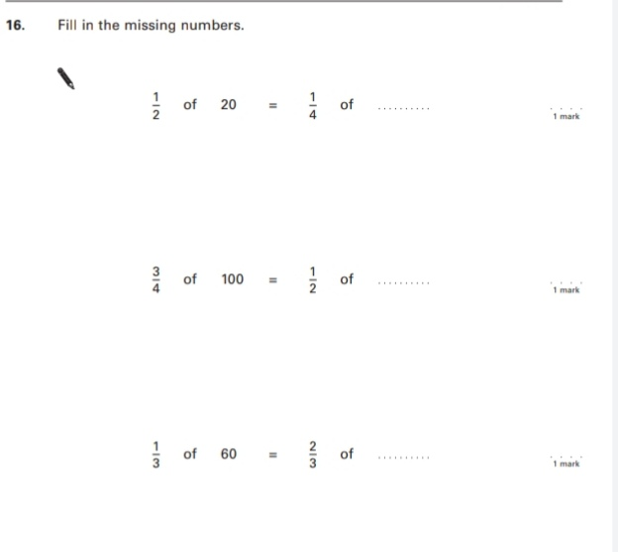
Key Stage 3: 2003 Paper 2 Level 3-5
2.
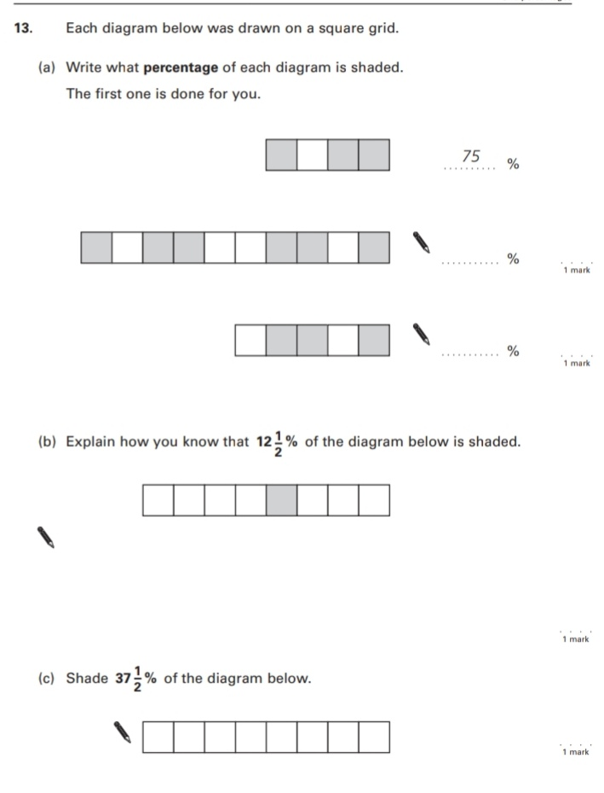

Key Stage 3: 2003 Paper 1 Level 4-6
3.
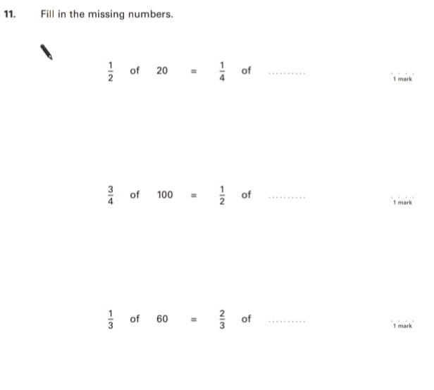
4.
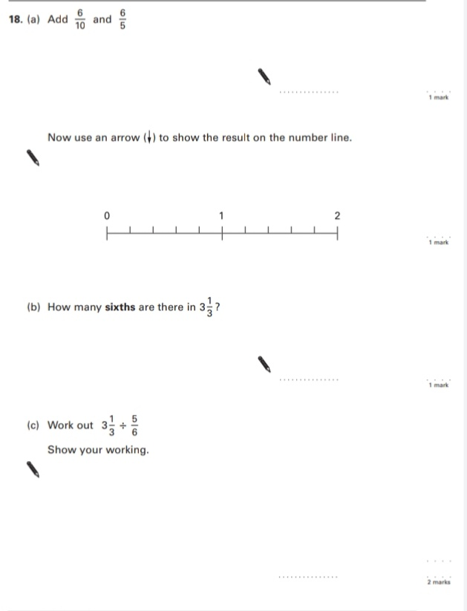
Key Stage 3: 2003 Paper 2 Level 4-6
5.
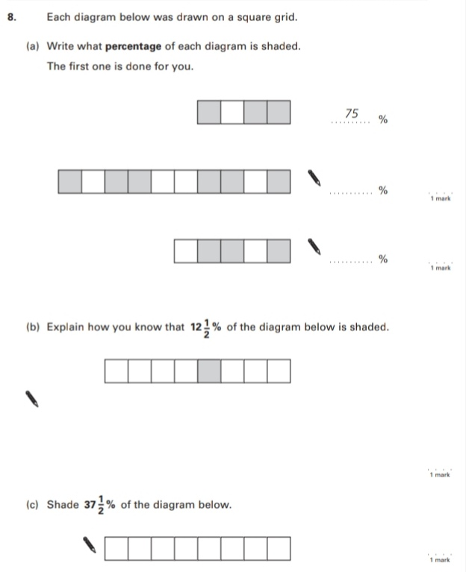
6.
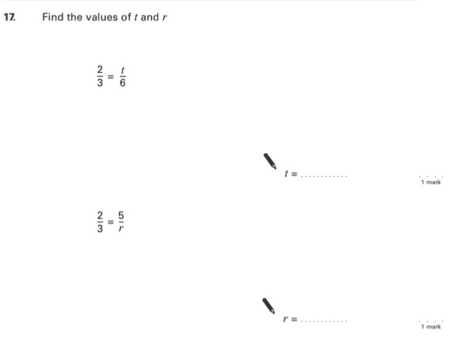
Key Stage 3: 2004 Paper 1 Level 3-5
7.
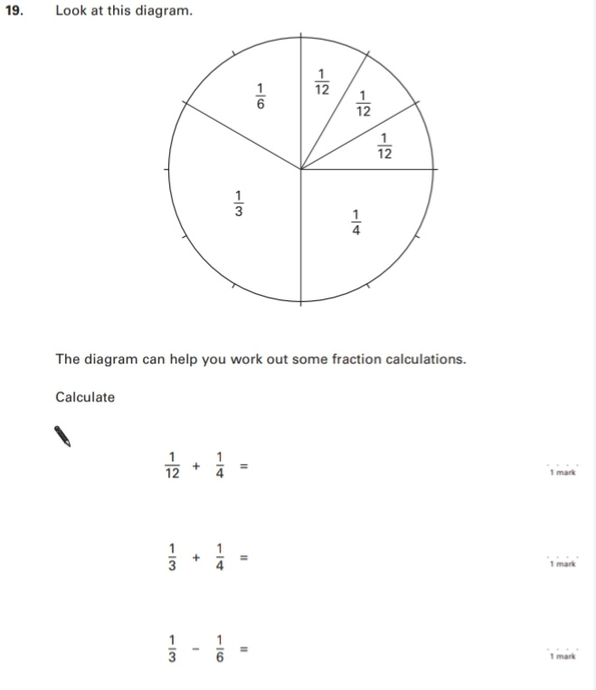
Key Stage 3: 2004 Paper 1 Level 4-6
8.
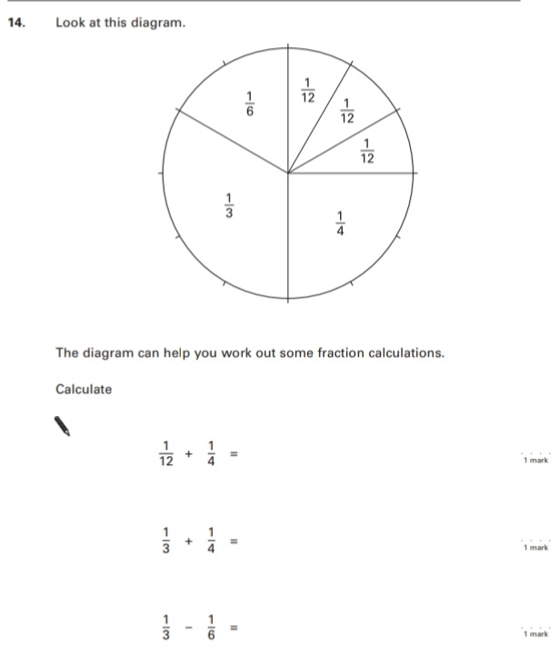
9.
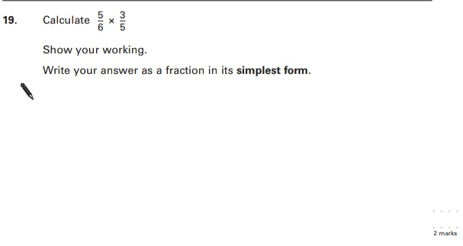
Key Stage 3: 2005 Paper 1 Level 3-5
10.
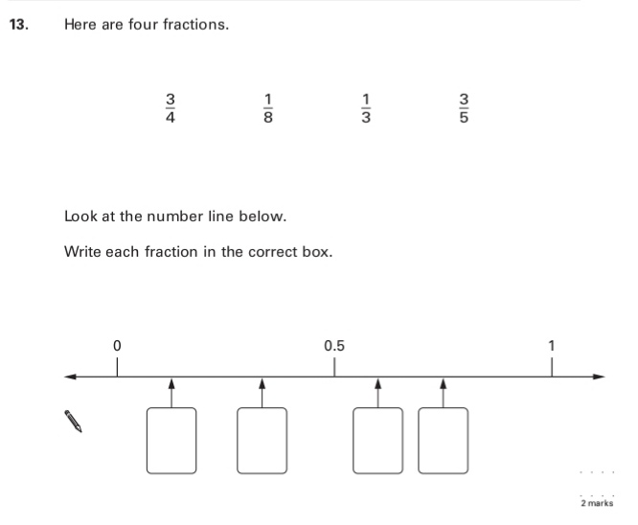
11.
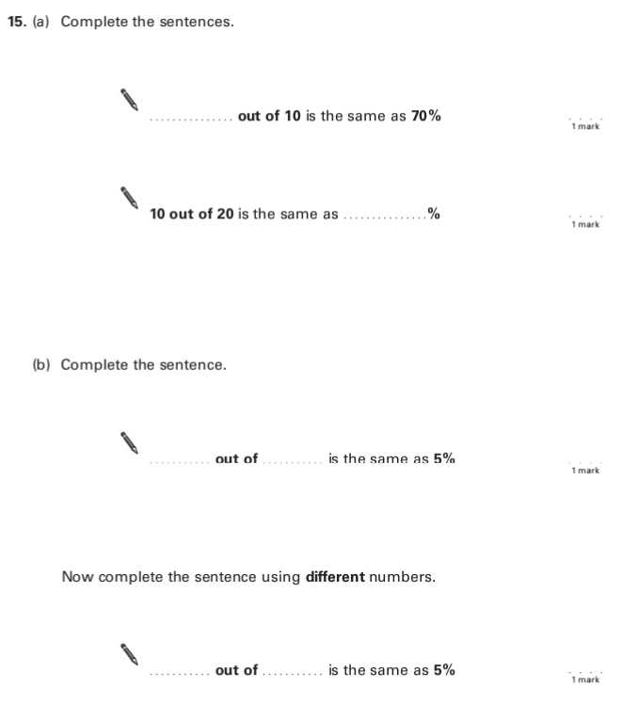
Key Stage 3: 2005 Paper 2 Level 3-5
12.
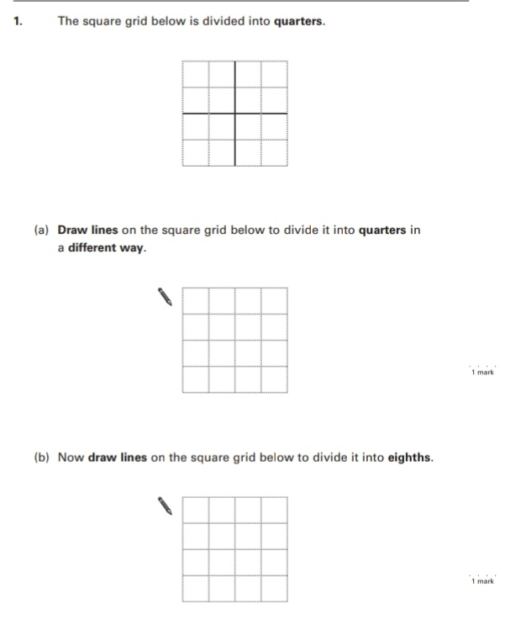
Key Stage 3: 2005 Paper 1 Level 4-6
13.
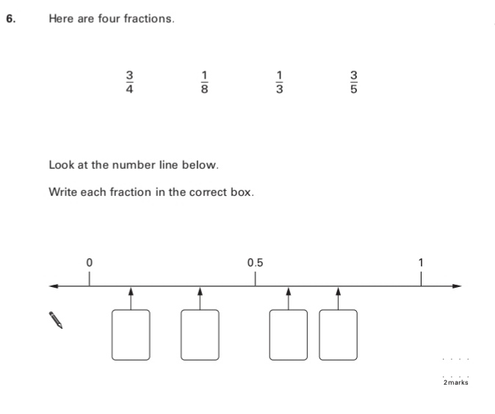
14.
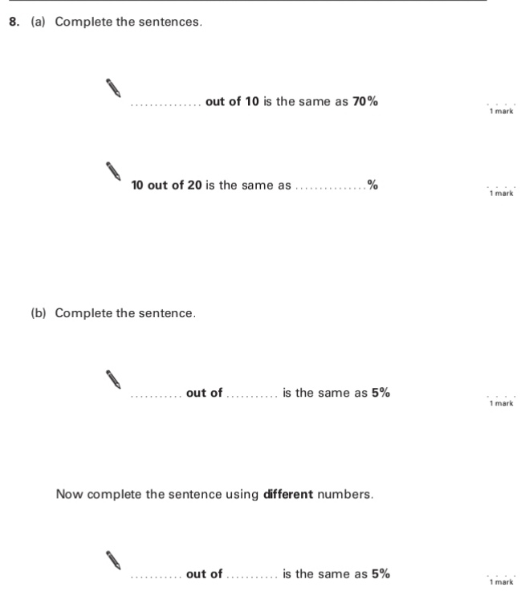
15.
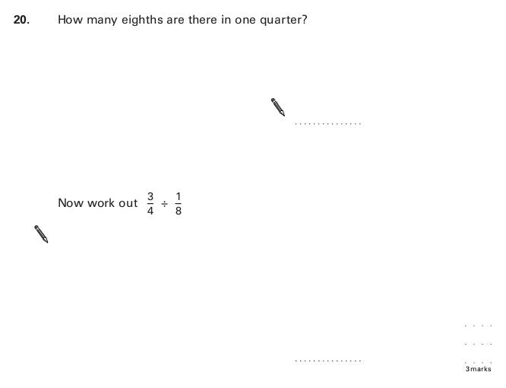
Key Stage 3: 2006 Paper 1 Level 3-5
16.
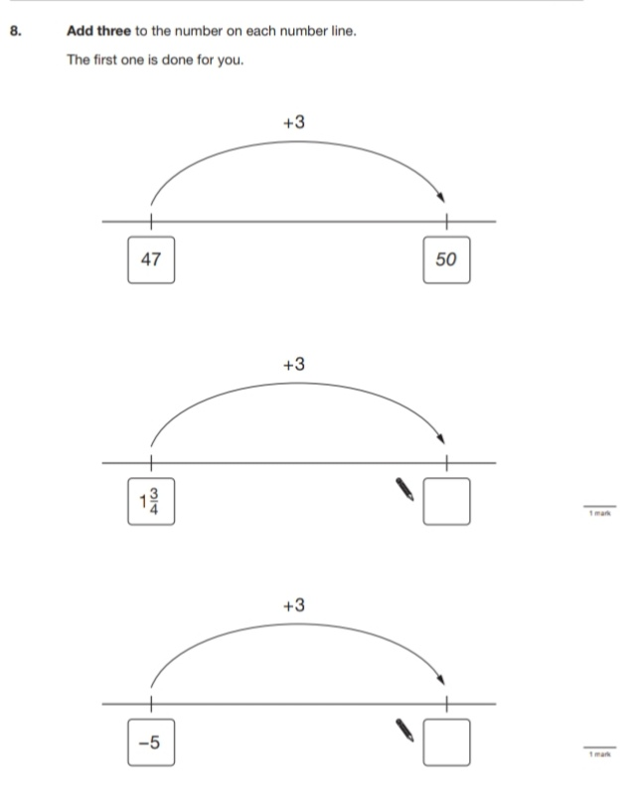
Key Stage 3: 2006 Paper 1 Level 4-6
17.
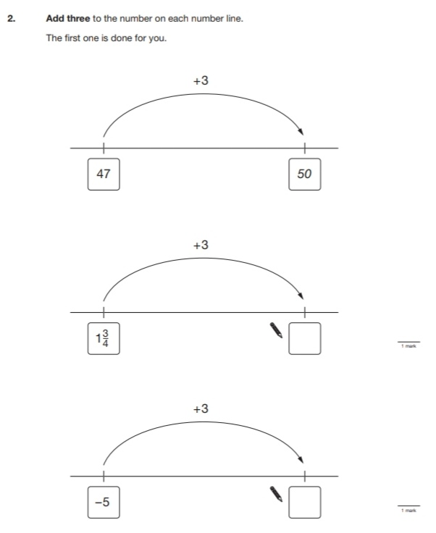
18.
Key Stage 3: 2007 Paper 1 Level 3-5
19.
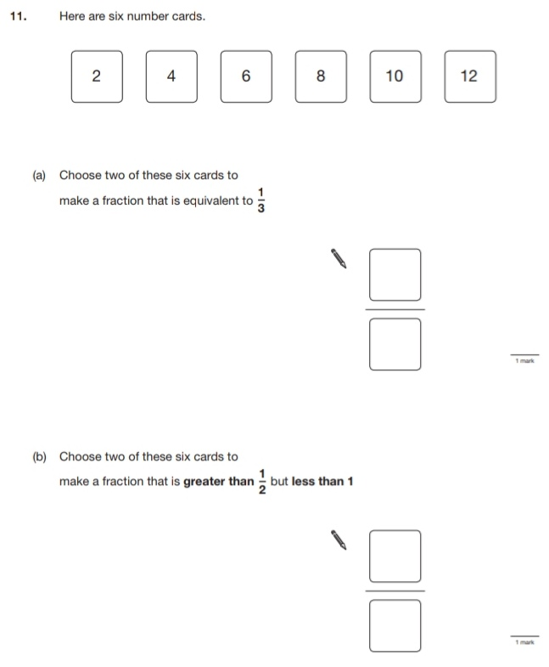
20.
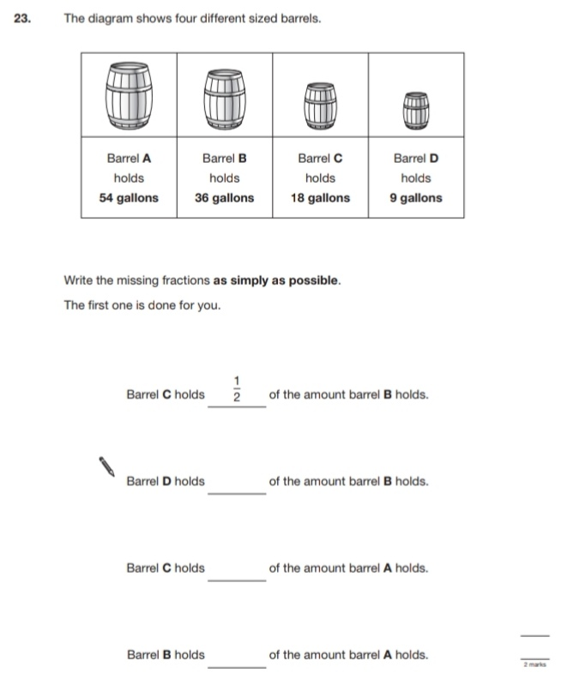
Key Stage 3: 2007 Paper 1 Level 4-6
21.
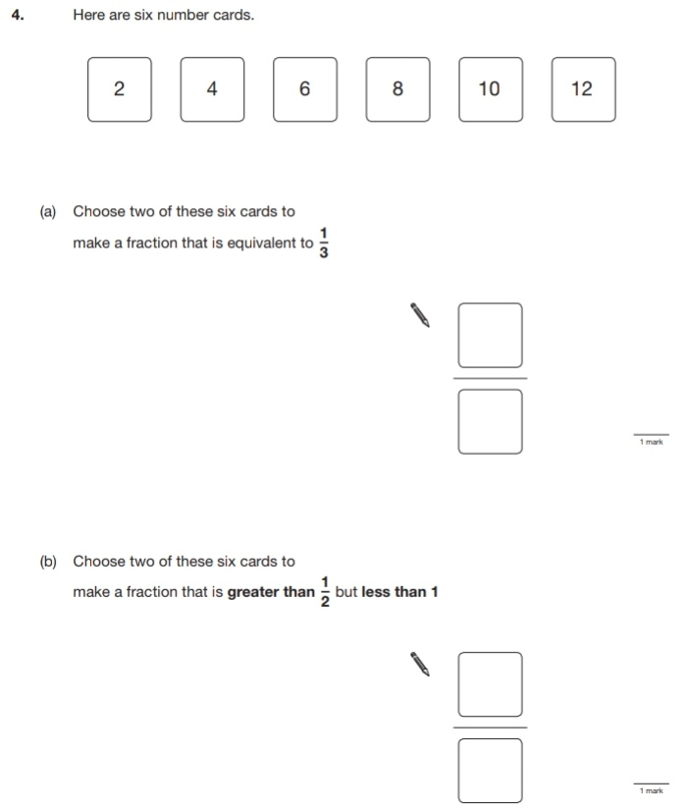
22.
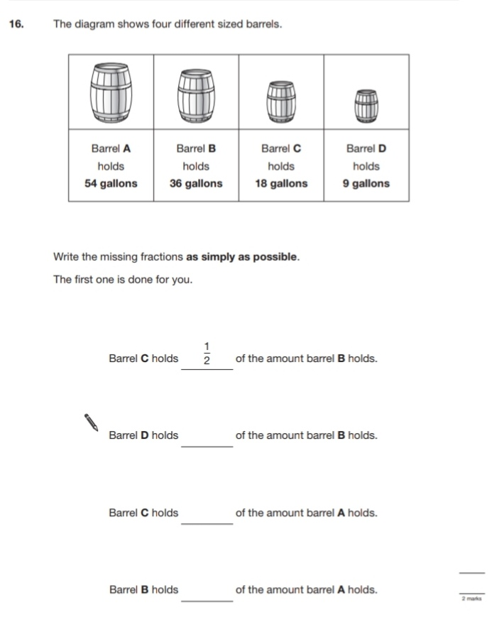
23.
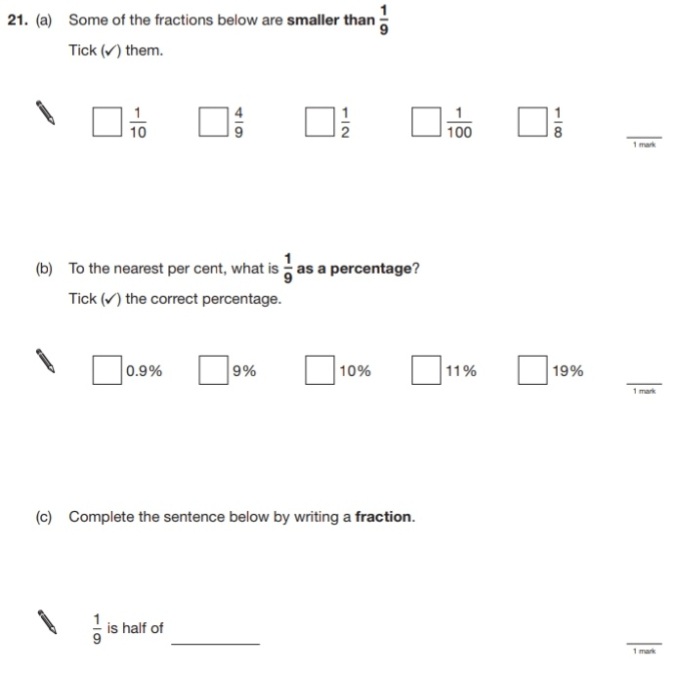
24.
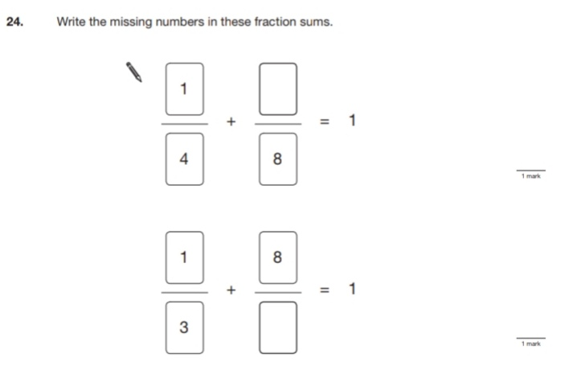
Key Stage 3: 2008 Paper 1 Level 3-5
25.
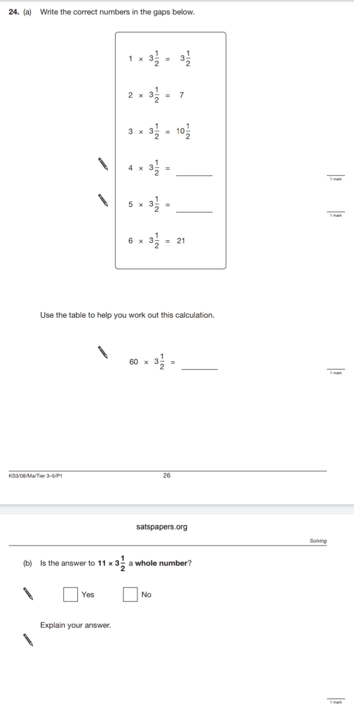
Key Stage 3: 2008 Paper 1 Level 4-6
26.
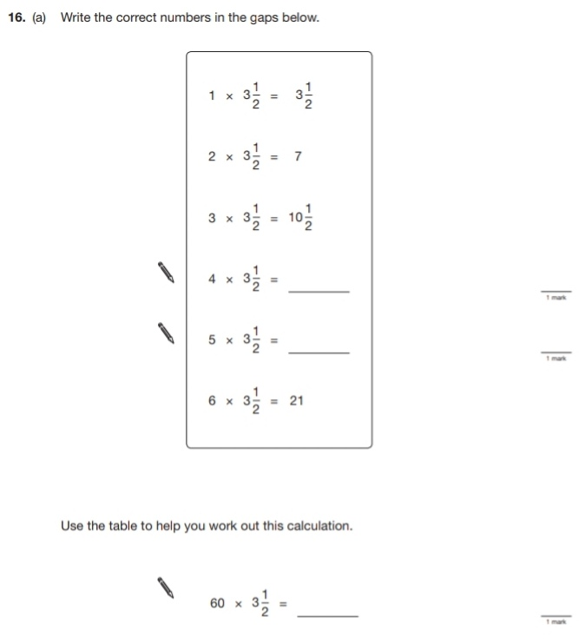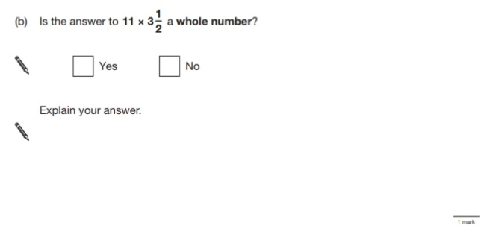
27.
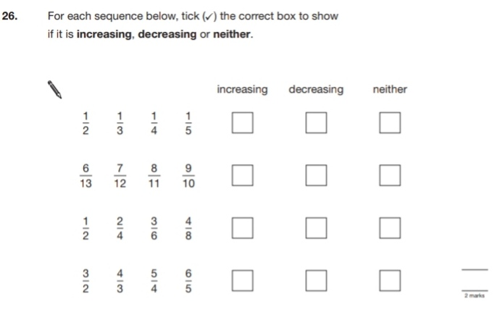
28.
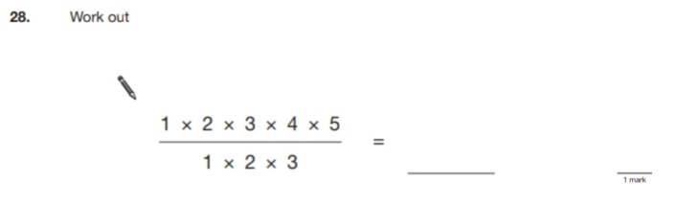
Key Stage 3: 2009 Paper 2 Level 3-5
29.
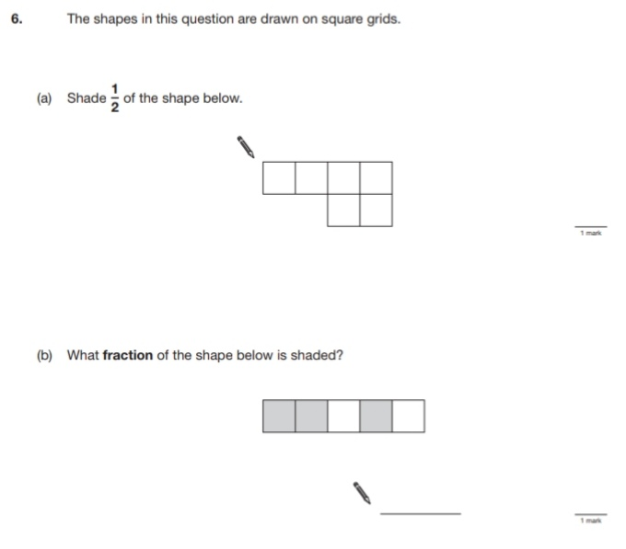
Key Stage 3: 2009 Paper 1 Level 4-6
30.
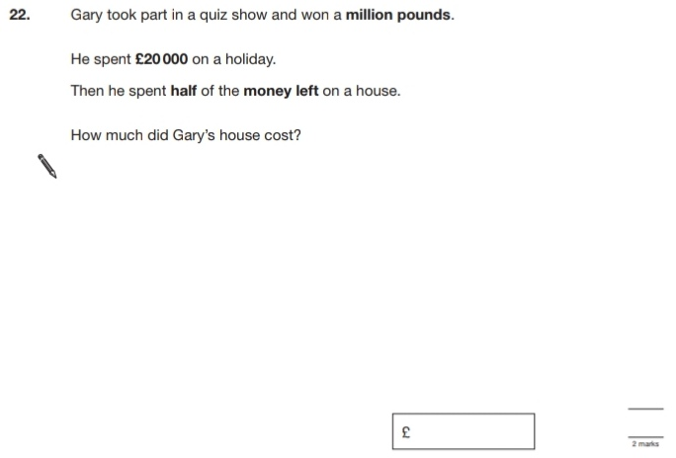
31.
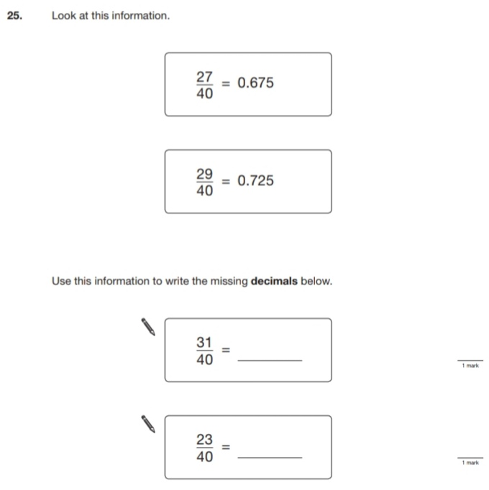
Key Stage 3: 2009 Paper 2 Level 4-6
32.
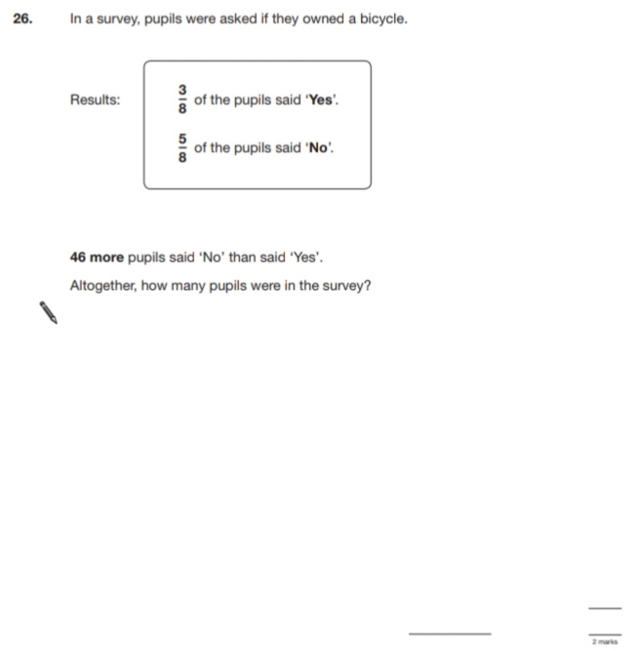
Key Stage 3: 2010 Paper 1 Level 3-5
33.
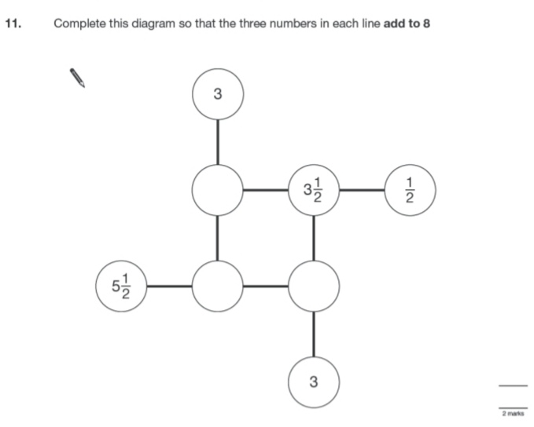
Key Stage 3: 2010 Paper 2 Level 3-5
34.
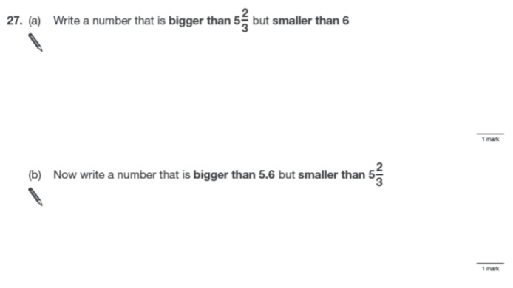
Key Stage 3: 2010 Paper 1 Level 4-6
35.
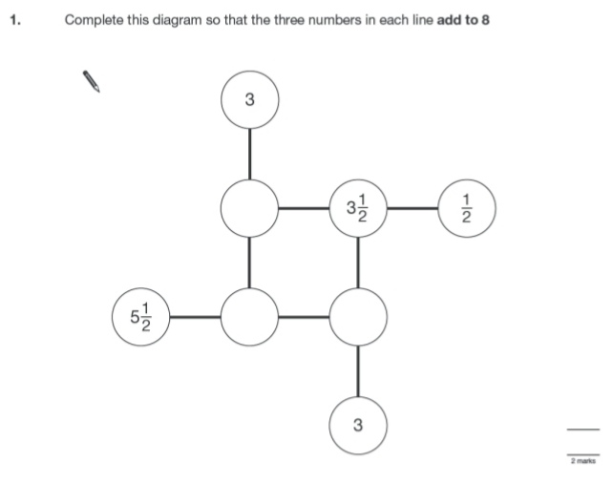
36.
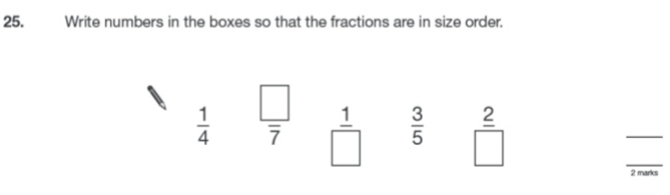
Key Stage 3: 2010 Paper 2 Level 4-6
37.
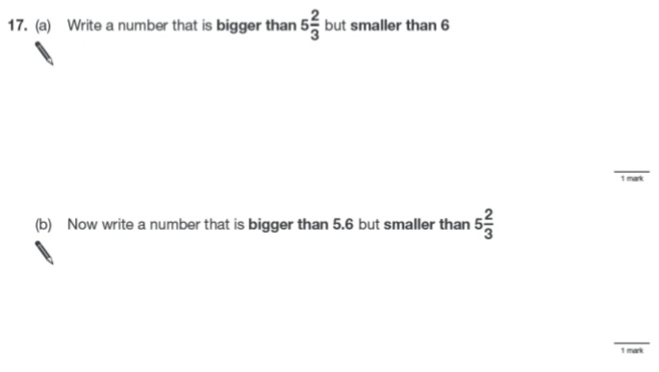
Key Stage 3: 2011 Paper 1 Level 4-6
38.
